BEGIN TITLE HERE IF IT REQUIRES THREE LINES.
BEGIN HERE IF ONLY TWO LINES.
USE ALL CAPITAL LETTERS
by

Your Name (First Middle Last)

A professional paper submitted in partial fulfillment
of the requirements for the degree

of

Master of Science

in

Science Education

MONTANA STATE UNIVERSITY
Bozeman, Montana

Month and Year ETD is accepted by MSSE Program (e.g. August 2024)

©COPYRIGHT
by
Your Name (First Middle Last)
Year
All Rights Reserved

DEDICATION
Delete if not using.
Dedication may be no longer than one page and should precede the acknowledgments page.
The “Front Matter Title” accessibility style is used on this page’s title. There is no space above the title and a triple space below.
Paragraphs on this page are left aligned or justified, with the first line indented, and single spaced. There should be no additional space between paragraphs.

ACKNOWLEDGEMENTS
Delete if not using.
Acknowledgments are limited to one page. Consider that you may need to include a funding acknowledgement.
The “Front Matter Title” accessibility style is used on this page’s title. There is no space above the title and a triple space below.
Paragraphs on this page are left aligned or justified, with the first line indented, and double spaced. There should be no additional space between paragraphs.

VITA and/or AMERICAN INDIAN HERITAGE
Delete if not using.
If you include a vita, it can include background information such as full name of author, education, place of birth, and family heritage. The vita should be written in essay form in the third person and may not exceed one single-spaced page. Note that your document will be published in an open access database and that this information will be public.
American Indian/Alaska Native students wishing to include heritage and tribal information may do so as part of a vita or as a separate single-spaced page.
The “Front Matter Title” accessibility style is used on this page’s title. There is no space above the title and a triple space below.
Paragraphs on this page are left aligned or justified, with the first line indented, and single spaced. There should be no additional space between paragraphs.

TABLE OF CONTENTS
- INTRODUCTION & BACKGROUND 1
Context of the Study 1
Focus Statement/Question 1
First Level Heading 1
Second Level Heading 1
Third Level Heading 1
- CONCEPTUAL FRAMEWORK 2
Style Formats 2
Tables and Figures 2
More Figure/Table Examples 3
- METHODOLOGY 4
Demographics 4
Treatment 4
Data Collection and Analysis Strategies 4
- DATA ANALYSIS 5
Results 5
- CLAIM, EVIDENCE, AND REASONING 6
Claims from the Study 6
Value of the Study and Consideration for Future Research 6
Impact of Action Research on the Author 6
REFERENCES CITED 7
APPENDICES 12
APPENDIX A TITLE 13
APPENDIX B TITLE 15

TABLE OF CONTENTS CONTINUED

LIST OF TABLES
Table Page
- Table 1. Data Triangulation Matrix. 4
- Table A1. Any tables or figures in the Appendices need to have titles and captions like they do in the body text. 15

LIST OF TABLES CONTINUED
Table Page

LIST OF FIGURES
Figure Page
- Figure 1. A screenshot of the format styles. Highlight your text and apply a style. There is a “caption above” or “caption below” format style for figure/table captions. 2
- Figure 2. Overview of the 5E learning cycle model (Adapted from Knowledge Quest). 3
- Figure 3. Normalized gains for concept mastery and scientific reasoning, (N=10). Note. FORT: Montana State University formal reasoning test. FMCE: Force and motion conceptual evaluation. EMCS: Energy and momentum conceptual survey. 3

LIST OF FIGURES CONTINUED
Figure Page

GLOSSARY or NOMENCLATURE
Delete if not using. If using, match spacing of entries to List of Tables/List of Figures where each entry is single spaced, but there is a double space between entries.

ABSTRACT
Begin abstract here. Single spaced and no more than 350 words. Indent first line one full tab. The abstract must contain the following elements: (1) statement of the problem, (2) procedure or methods, (3) results, and (4) conclusions. Mathematical formulas, abbreviations, diagrams, and other illustrative materials should not be included. It should be written to be understood by a person who does not have expertise in the field.
CHAPTER ONE

INTRODUCTION & BACKGROUND

Context of the Study
Paragraph text.

Focus Statement/Question
Paragraph text.

First Level Heading
Please follow standard option formatting rules while using this template. You are expected to follow all the rules laid out on the Sample Pages. This template is a reduced version of the Sample Pages for ease of use.

Second Level Heading
The Styles in the Home tab are pre-set for all titles and headings, plus table and figure captions and long quotes. See the accessibility guidelines and template video on the standard option formatting rules webpage for information on using these headings.
Third Level Heading.
If you have technical questions on formatting, visit our “How Do I…” formatting help page or use any search engine (such as Google) for additional information. If you need clarification on formatting rules, please feel free to reach out to the MSSE formatting advisor in the MSSE Office.
CHAPTER TWO

CONCEPTUAL FRAMEWORK

Style Formats

Tables and Figures
With The Graduate School’s template, you can use the format styles for the chapter titles; first, second, and third level headings; long quotes; and figure/table captions (above and below).

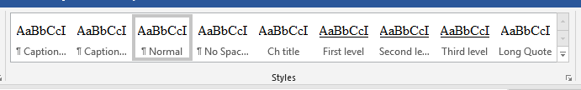
Figure 1. A screenshot of the format styles. Highlight your text and apply a style. There is a “caption above” or “caption below” format style for figure/table captions.
Your text would continue with a triple space between the caption and the body text. Captions can be above or below – just be consistent. Figures and tables fit inside the page margin requirements.
To use the third level style heading, put heading on separate line, apply Third level, move your cursor to the end of the heading and click “Ctrl+Alt+Enter.”

More Figure/Table Examples
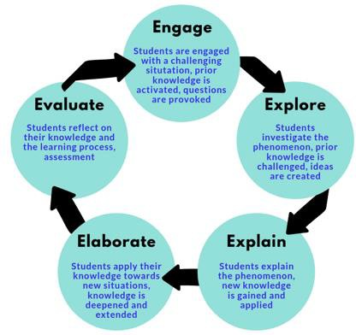
Figure 2. Overview of the 5E learning cycle model (Adapted from Knowledge Quest).
There should be a triple space between figure/title captions. Be sure to add Alt Text to tables and figures.

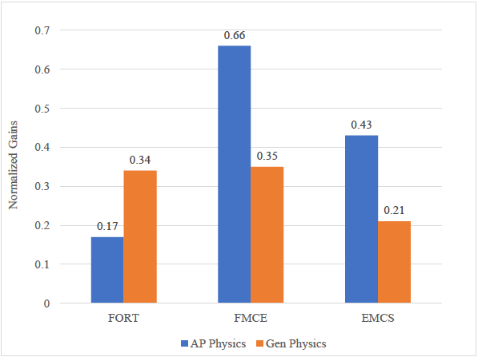
Figure 3. Normalized gains for concept mastery and scientific reasoning, (N=10). Note. FORT: Montana State University formal reasoning test. FMCE: Force and motion conceptual evaluation. EMCS: Energy and momentum conceptual survey.
Table 1. Data Triangulation Matrix.
Watershed | Data Source #1 | Data Source #2 | Data Source #3
How does the incorporation of an anchoring phenomenon to drive  instruction via the 5E Learning Cycle affect student growth | Pre- and Post- Tests | Lab Quiz Results | Formative Assessments via CATs
What affect does the incorporation of an anchoring phenomenon to drive  instruction via the 5E Learning Cycle have on student engagement? | Engagement Tally Sheet | Student Surveys and Interviews
How does the incorporation of an anchoring phenomenon to drive instruction via the 5E Learning Cycle affect students’ attitudes toward  science? | TOSRA Survey | Student Surveys and Interviews

CHAPTER THREE

METHODOLOGY

Demographics
Paragraph text.

Treatment
Paragraph text.

Data Collection and Analysis Strategies
Paragraph text.

CHAPTER FOUR

DATA ANALYSIS

Results
Paragraph text.

CHAPTER FIVE

CLAIM, EVIDENCE, AND REASONING

Claims From the Study
Paragraph text.

Value of the Study and Consideration for Future Research
Paragraph text.

Impact of Action Research on the Author
Paragraph text.

REFERENCES CITED

References begin here. References are single-spaced with a double-space in between citations. Students choose their citation style, typically in discussion with their advisor. All references must follow the same, consistent citation style.
This page is an example of how to format your references if you DO have appendices. Use a References Cited divider page as shown in this example ONLY if you also have appendices. Use the “End Matter Title” accessibility style for this title in order for it to feed correctly into the automatic Table of Contents at the beginning of the document.
If you include URLs in your references, format them consistently throughout. For example, this URL https://www.montana.edu/etd/ and this URL https://www.montana.edu/etd/ are formatted differently. Pick one of these styles for your ETD and use it consistently throughout.
Smith, J. D. (2020). The art of fiction: A comprehensive guide. Fiction Publications.
Johnson, A. B., & Thompson, C. D. (2019). The effects of examples on mental health. Journal of Example Psychology, 25(2), 123-145. https://doi.org/
National Institute of Example Studies. (2022). Climate change and its impacts. https://www.example.gov/climate-change-impacts
NGSS Lead States. (2013). Next Generation Science Standards: For states, by states. Washington, DC: The National Academies Press.

NGSS Lead States. (2013). Next Generation Science Standards: For States, By States (insert specific section title(s) being used if not referring to entirety of the NGSS). Retrieved from https://www.nextgenscience.org/

The Wonder of Science. (n.d.). Retrieved from https://thewonderofscience.com/

REFERENCES CITED
References begin here. References are single-spaced with a double-space in between citations. Students choose their citation style, typically in discussion with their advisor. All references must follow the same, consistent citation style.
This page is an example of how to format your references if you DO have appendices. Use a References Cited divider page as shown in this example ONLY if you also have appendices. Use the “End Matter Title” accessibility style for this title in order for it to feed correctly into the automatic Table of Contents at the beginning of the document.
If you include URLs in your references, format them consistently throughout. For example, this URL https://www.montana.edu/etd/ and this URL https://www.montana.edu/etd/ are formatted differently. Pick one of these styles for your ETD and use it consistently throughout.
Smith, J. D. (2020). The art of fiction: A comprehensive guide. Fiction Publications.
Johnson, A. B., & Thompson, C. D. (2019). The effects of examples on mental health. Journal of Example Psychology, 25(2), 123-145. https://doi.org/
National Institute of Example Studies. (2022). Climate change and its impacts. https://www.example.gov/climate-change-impacts
NGSS Lead States. (2013). Next Generation Science Standards: For states, by states. Washington, DC: The National Academies Press.

NGSS Lead States. (2013). Next Generation Science Standards: For States, By States (insert specific section title(s) being used if not referring to entirety of the NGSS). Retrieved from https://www.nextgenscience.org/

The Wonder of Science. (n.d.). Retrieved from https://thewonderofscience.com/

APPENDICES

APPENDIX A

APPENDIX A TITLE
Appendix A content begins here.
Continue to follow ETD formatting in the Appendices where applicable. For example, original writing like a paragraph of text and a few figures should be formatted according to Graduate School guidelines. A copy of a letter that was sent as part of a student’s research should be formatted exactly as it was sent.
Table A1. Any tables or figures in the Appendices need to have titles and captions like they do in the body text.
Fruit | Quantity (per day) | Color
Apple | 2 | Red
Banana | 1 | Yellow
Orange | 3 | Orange
Strawberry | 10 | Red
Kiwi | 2 | Green

Tables and figures in the appendices can be numbered in several different ways. They can continue numbering from the body text; they can restart numbering at 1; they can restart numbering but be proceeded by the letter of the appendix such as in this example. Pick one way of numbering and be consistent.

APPENDIX B

APPENDIX B TITLE
Appendix B content begins here.

APPENDIX

APPENDIX TITLE
Appendix content begins here.
This is an example of how to format an appendix if you only have ONE appendix.

