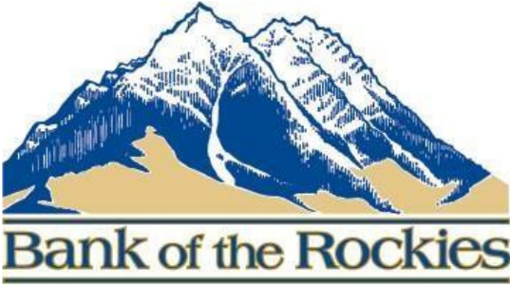

Bank of the Rockies
4-H Scholarship

Bank of the Rockies is offering one scholarship of $250 for the upcoming 2025 fair year. The scholarship is open to anyone with a large animal project that will be presenting their animal at the Fergus County Fair. The scholarship can be used towards anything for your project: show supplies, feed, equipment, animal purchase, etc.

Name:_______________________________________
Phone Number:________________________________
Email:_______________________________________
4-H project:___________________________________
4-H club:_____________________________________

- If awarded the scholarship, what would you use the money for? (Please provide an Income/Expense projection for your project.)

- Explain your plan for your project for the upcoming year. (What you’re going to feed, feed ratio, target ADG and weight.)

- List all organizations, sports, extra-curricular activities involved in and awards, achievements received in each.

- Why should you be awarded this scholarship from Bank of the Rockies?

When completed, drop off or mail into bank or your extension office:
Bank of the Rockies; Tyler Hicks
401 W Main St, Lewistown, MT 59457

