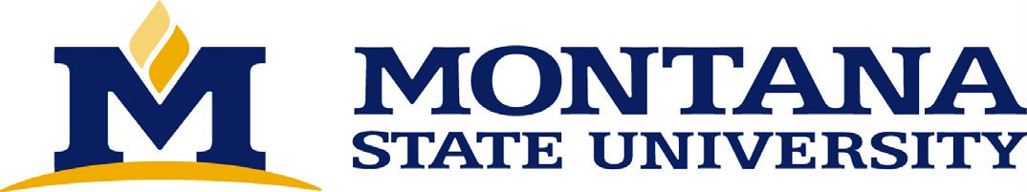
Institutional Animal Care & Use Committee
Visual Image or Sound Recordings of Animals Policy

- Purpose
This policy describes the allowable use of recording devices in any area where animals are housed, tested, or used at Montana State University (MSU) including, animal facilities, university vehicles/conveyances, and field study locations and provides university personnel guidance on how to best present and share recordings involving live or dead animals or their parts.
This policy is intended to protect the confidentiality and integrity of MSU research, to assure respect for the privacy and safety interests of staff and students, and to prevent misleading representation of MSU animal use and related policies and procedures.
- Scope
This policy applies to all individuals involved in animal research, teaching, and management at MSU.
III. Policy

The use of any recording device (e.g., film camera, digital camera, phone, digital recorder, sound recorder, live streaming equipment) to record sounds or images of animals or animal use areas is prohibited unless one of the following exceptions apply:

- When performed by the Principal Investigator (PI) or designee when required for University-sanctioned scientific reasons (e.g., publications, laboratory documentation, grant submissions).
- When performed by the PI or designee for the purpose of recording instructional activities.
- When performed by or at the direction of the facility director, the Attending Veterinarian (AV), the Institutional Animal Care and Use Committee (IACUC) or Research Integrity and Compliance (RIC) for the purpose of diagnosing or documenting clinical disease, veterinary care or treatment.
- When performed by or at the direction of the facility directors for surveillance of animals for purposes of animal care and husbandry. Facilities conducting video surveillance must comply with MSU’s Video Surveillance Policy.
- When performed by personnel in consultation with the facility director when required to document the condition of facilities, compliance, or animal welfare issues.
- When performed by IACUC members or RIC office staff to document conditions during IACUC inspections.
- When performed by government inspectors (e.g., USDA Veterinary Medical Officer).
- Images and/or recordings must comply with the MSU Film, Photography, and Audio Recording Policy..
- University personnel or University students who wish to record or allow recording by others (e.g. journalists) in animal use areas for reasons not described in the above list of exceptions must involve the f directors of the IACUC facilities and RIC prior to recording. University personnel are also strongly encouraged to work with University Communication subsequent to the information dissemination process by contacting the University’s Communications Director.

